Procedure for New version of CompuTax - Installation

KEY STEPS

- Step1.-Configuration Requirement
- Step 2- Installation
- Step 3- Import data from old software
- Step 4- ActiveX Setup
- Step 5- LAN Installation procedure.
- Step 6- Stop running of the old software

Annexure-A New Concept of Master Database
Annexure-B Import Procedure

Step 1. Configuration Requirement
- Windows -2000 SP 4 or later (Professional, Server, Advance, Datacenter service edition)
- Windows XP SP 2 or later(Professional, Home, Media edition).
- Windows 2003 SP 1 or later (Standard, Enterprise, Datacenter, SBS edition).
- Windows Vista & Windows 7
- Microsoft Internet Explorer 6.0 or later

Step 2- Installation
Insert CD and wait for few seconds. It will auto run and a screen will appear on your screen.. Follow the instruction on the screen. Default drive for installation is c:\. It is strongly recommended to install the software on d:\.

Step 3- Import data from old software

Existing users are required to import the data from the existing data. Import process is enclosed in annexure-B. We strongly recommend to go through to Concept of Master Database before starting import process. After Import of the record see the Import log report.

Step 4 – ActiveX Setup
Activex control is required to be install to view the reports etc. After login screen a screen will open “Gateway of Compuoffice”. In middle bottom of this screen a link is given to install the activex. If activex is already installed, link will not display. Click on this link to install the activex.

Step 5- LAN Installtion Procedure.
For running the software on LAN, copy the icon of CompuOffice from the desktop where Compuoffice is installed and paste on the desktop of the desired computer. Nothing else is required to done. When software will run on this computer first time, Activex is required to install on this computer also. When it run on this computer link will display as explained in the above step.

Step 6- Stop running of the old software
Last not least, after successful installation stop the running of the years which are import in the new software. It is necessary because if work is carry on in both software, it will not be possible to merge the data. The work done in the Computaxonline cannot be update in the old software. There is a folder old_soft in our installation cd, Open this folder and copy all the file and paste in old computax folder of the old software. It will stop the working in the old software, for the years which are import in the new software.

Annexure-A

New Concept of master database
Now in Compuoffice the concept of Master database has been implemented. There is two major change in Master data.
- The permanent information will be kept only at one place. The permanent information of client will share by all the software. At present it required to feed name and address again and again in individual software. Now the permanent information will be store in Master data and will share by all software.
- At present permanent information are kept yearwise. However user is not required to feed information year to year, the permanent information is copied in the next year while updating the next year. Now the permanent information are common. If there is change in any permanent information, software automatically keep the track of the changes.
Merging the Permanent Information during the process of Import

A. While importing computax
- For first year it will import all data of that year.
- While importing next year it will compare PAN. If a PAN is already import then it will not import the permanent information as it is already been import from other assessment year. But it will import the figures of computation of that assessment year.

B. While importing other than CompuTax
- The key for import is PAN. While import if a client is exist with same PAN in Master Database, it will import the client to existing code.

Case 1 - M/s XYZ & Co. has code as under:

Code | PAN | Software
101 | ABCFX1234E | CompuTax
X-100 | ABCFX1234E | CompuTds
1001 | ABCFX1234E | CompuFBT

It is recommended to import CompuTax first. When records of CompuTax will import, a record of M/s Xyz & Co. is added in the master data. When you import the data of CompuTds, however code of XYZ & co. is different, but it have same PAN. CompuTax online will import XYZ & co. in code 101. There will be no reference of code X-100 in new master data. The additional permanent information of CompuTds like details of Responsible person will append to Master Code 101. The same position will be with FBT record. It will also attach with code 101 in Master data.

There may be a position like that
Case 2
Code | PAN | Software
A-67E | ABCFX1234E | CompuTax
A-67E | ABCFX1243E | CompuTds
In this case code in both software are same, but PAN number is fed different
. While importing, in this case tds import as a A-67EX

Case 3

Code | PAN | TAN | Software
A-67E | ACWPK8787R | JPRM12345E | CompuTax
A-67F | ACWPK8787R | JPRM12345E | CompuTds
A-67E | ACWPK8787R | JPRN12354F | CompuTds

In this case PAN number are same but TAN number are different as bank case
while importing in this case code A-67F import in code A-67E and code A-67E
import as a A-67EX
Annexure-B

Import Procedure

Before import data from old software it is recommended to update old software from service pack.

For import data from old software open Compuoffice Online folder and run
MigartionCallUtility.exe then a window appear as like below

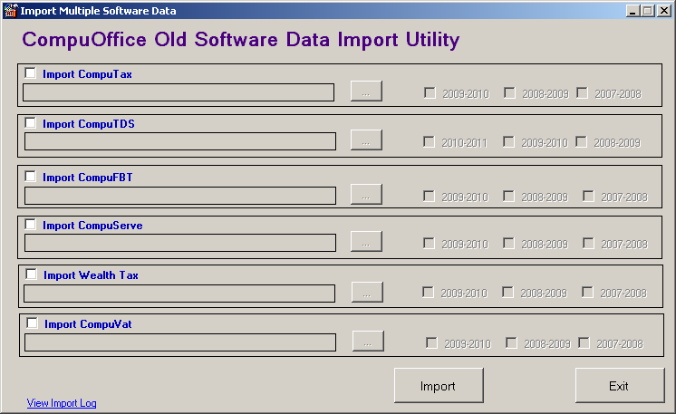

Check import computax software and select old data software Path through browser button and select assessment year then click import button for data importing from old software to new version. Data of Billing will be import separately.

NOTE->
- After completion of the import process there may be some records which are not import due to some reason.. These remaining records can be import through Remaining data are import through utility option from Gateway of CompuOffice then follow Alternate Process of import (Given Below)

Alternate Process of import

- Go in the Utility
- Select “Import Data From Old Software’s”
- Select Assessment Year
  - It is recommended to import Computax A.Y. 2009-10 First
  - After this import CompuTax A.Y. 2008-09 then A.Y. 2007-08
- Select the directory where CompuTax is installed; Select only the main directory(C:\computax) not the database directory(C:\computax\database).
- After this press OK
- A list of clients from existing Software will display. The default is to show clients which are not import (called Not merge). There is option to show merged and ALL clients. If a client is once import it will marked as Merged. If any code is need to import again, select the option of Merged. It will show all the code which are already import. If you select to import again all or selected code from the list, it will give warning and marked these code as Not Merged. If due to any fault import process break. Then when import process is again started balance code which is not import again will show under Not merged.
- Click on Select all, then press Ok
- It will take time to import the record. Record will import one by one. If due to any reason import process break, then it is required to start again by same method. The records once imported will not importing again.
- After import of record for A.Y. 2009-10, import records from other assessment year
- After importing CompuTax, import other software one by one
- Except CompuTax in old software status of client was not defined. While importing the data, status is being determined on fourth character. In some cases same fourth character is allotted (1) company public interested, Private company. (2) AOP/ Co-Operative. In both cases it will prompt for status.
Bill Import process

Open Bill Import Utility. Select Computax Folder with A.Y. Press OK. Then a list appear of Non Computax Clients. Then Select Mark As Delete. If you want to change code then enter New Code through Given Code No. field. Otherwise select Check Box for Same Code then press ok for Import Bill Data Process.

Report of Data Import

However the client record is import to same code in Master data, as they are in the existing software. But the case where different codes are allotted in different software, it merge the codes on the basis of PAN and other key factors. To view this report Go in Utility>Import data from old software. In bottom there is a section “Import log Report” you can see the report. A report is generated showing existing old software code, Master database code, Name, PAN, Fathers Name. From this report you can find out the code with which old client data is merged.

